**An introduction to Flowcharts**

**What is a Flowchart?**

Flowchart is a graphical representation of an algorithm. Programmers often use it as a program-planning tool to solve a problem. It makes use of symbols which are connected among them to indicate the flow of information and processing.

The process of drawing a flowchart for an algorithm is known as “flowcharting”.

**Basic Symbols used in Flowchart Designs**

Terminal: The oval symbol indicates Start, Stop and Halt in a program’s logic flow. A pause/halt is generally used in a program logic under some error conditions. Terminal is the first and last symbols in the flowchart.

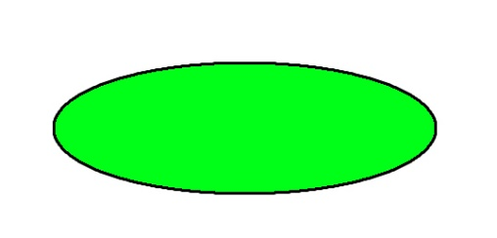

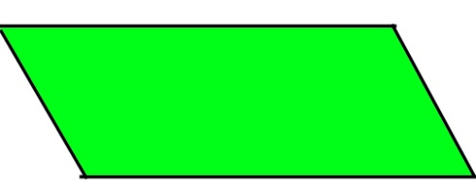Input/Output: A parallelogram denotes any function of input/output type. Program instructions that take input from input devices and display output on output devices are indicated with parallelogram in a flowchart.

Processing: A box represents arithmetic instructions. All arithmetic processes such as adding, subtracting, multiplication and division are indicated by action or process symbol.

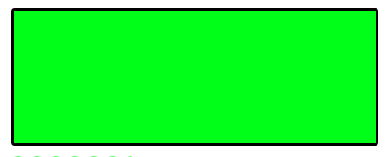

Decision Diamond symbol represents a decision point. Decision based operations such as yes/no question or true/false are indicated by diamond in flowchart.

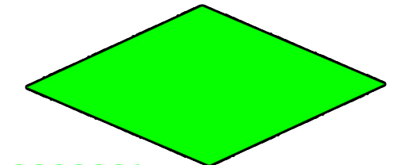

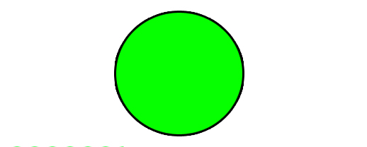Connectors: Whenever flowchart becomes complex or it spreads over more than one page, it is useful to use connectors to avoid any confusions. It is represented by a circle.

Flow lines: Flow lines indicate the exact sequence in which instructions are executed. Arrows represent the direction of flow of control and relationship among different symbols of flowchart.

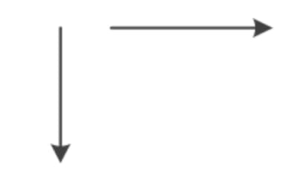

**Rules For Creating Flowchart :**

A flowchart is a graphical representation of an algorithm.it should follow some rules while creating a flowchart

**Rule 1**: Flowchart opening statement must be ‘start’ keyword.

**Rule 2**: Flowchart ending statement must be ‘end’ keyword.

**Rule 3**: All symbols in the flowchart must be connected with an arrow line.

**Rule 4**: The decision symbol in the flowchart is associated with the arrow line.

**Advantages of Flowchart:**

* Flowcharts are a better way of communicating the logic of the system.
* Flowcharts act as a guide for blueprint during program designed.
* Flowcharts help in debugging process.
* With the help of flowcharts programs can be easily analyzed.
* It provides better documentation.
* Flowcharts serve as a good proper documentation.
* Easy to trace errors in the software.
* Easy to understand.
* The flowchart can be reused for inconvenience in the future.
* It helps to provide correct logic.

**Disadvantages of Flowchart:**

* It is difficult to draw flowcharts for large and complex programs.
* There is no standard to determine the amount of detail.
* Difficult to reproduce the flowcharts.
* It is very difficult to modify the Flowchart.
* Making a flowchart is costly.
* Some developer thinks that it is waste of time.
* It makes software processes low.
* If changes are done in software, then the flowchart must be redrawn

**Example : Draw a flowchart to input two numbers from the user and display the largest of two numbers**

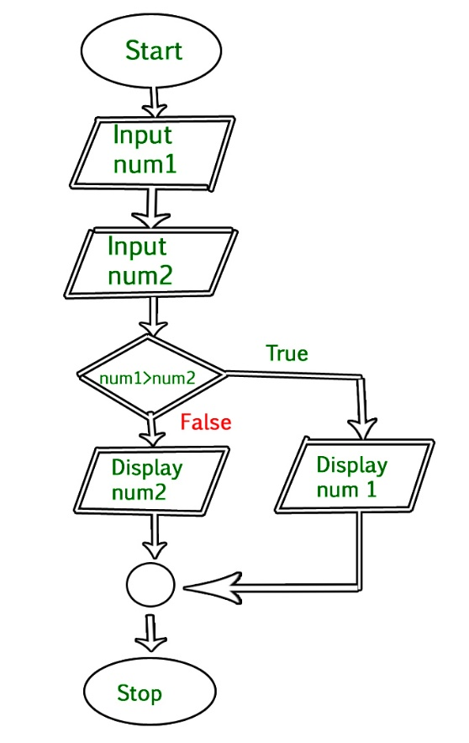

// C program to find largest of two numbers

#include <stdio.h>

int main()

{

int num1, num2, largest;

printf("Enter two numbers:\n");

scanf("%d%d", &num1, &num2);

if (num1 > num2)

largest = num1;

else

largest = num2;

printf("%d", largest);

}